Gold Price Analysis and Forecasting Using Time Series Techniques (2016–2026)

1. Introduction
Gold is one of the world's most important financial assets and has historically served as a store of value, a hedge against inflation, and a safe-haven investment during periods of economic uncertainty. Investors, central banks, and financial institutions closely monitor gold prices because they often reflect changes in global economic conditions, monetary policy expectations, inflationary pressures, and geopolitical risks.
Understanding gold price behaviour is essential for investment decision-making, portfolio management, and financial forecasting. Time series analysis provides a powerful framework for studying historical price movements and predicting future trends.
This project analyses daily gold price data from 2016 to 2026 using statistical and time-series techniques. The analysis focuses on trend identification, return analysis, volatility measurement, moving average analysis, correlation analysis, and forecasting using the Autoregressive Integrated Moving Average (ARIMA) model.

2. Objectives
The primary objectives of this project are:
- Analyse historical gold price movements from 2016–2026.
- Identify long-term market trends.
- Measure market volatility using rolling standard deviation.
- Calculate and analyse daily returns.
- Apply technical indicators such as moving averages.
- Examine relationships among price variables through correlation analysis.
- Forecast future gold prices using ARIMA models.
- Interpret major economic and geopolitical events affecting gold prices.

3. Dataset Description
3.1 Dataset Overview
The dataset contains daily historical gold market information covering approximately ten years of trading activity.
Attribute | Description
Dataset Name | Gold Historical Data
Period Covered | February 2016 – 2026
Number of Observations | 2,510 Trading Days
Frequency | Daily
Currency | USD

3.2 Variables Description
Variable | Description
Date | Trading Date
Open | Opening Price
High | Highest Price During Trading Day
Low | Lowest Price During Trading Day
Close | Closing Price
Volume | Trading Volume

Dataset Notes
The dataset consists of daily observations and is suitable for financial time-series analysis. The Close price is used as the primary variable for trend analysis and forecasting, while Open, High, Low, and Volume are utilized for correlation analysis.

4. Methodology
The project follows a structured analytical framework consisting of five stages.
Stage | Title | Activities
Stage 1 | Data Preparation | Import dataset, convert dates, sort observations, remove duplicates
Stage 2 | Trend Analysis | Study long-term gold price movement
Stage 3 | Risk Analysis | Calculate returns and volatility
Stage 4 | Technical Analysis | Moving averages and correlation analysis
Stage 5 | Forecasting | ADF test and ARIMA forecasting

5. Data Cleaning and Preprocessing
Before analysis, the dataset was cleaned and prepared to ensure accuracy and consistency.
The following preprocessing steps were performed:
- Converted the Date column into datetime format.
- Sorted observations chronologically.
- Checked for missing values.
- Removed duplicate observations.
- Verified dataset consistency.
These steps ensured that the data was suitable for time-series modeling and statistical analysis.

6. Exploratory Data Analysis and Summary Statistics
Before conducting trend and forecasting analysis, descriptive statistics were computed to understand the distributional characteristics of gold prices over the sample period.

Summary Statistics
Metric | Value
Mean Price | 1862.68
Median Price | 1767.35
Minimum Price | 1127.80
Maximum Price | 5318.40
Standard Deviation | 713.05
Skewness | 1.8084
Kurtosis | 3.4338

Interpretation
The average gold price during the study period was USD 1,862.68, while the median price was USD 1,767.35. Gold prices ranged from a minimum of USD 1,127.80 to a maximum of USD 5,318.40, indicating substantial price appreciation over time.
The standard deviation of 713.05 suggests considerable variability in gold prices. The positive skewness value of 1.8084 indicates that the distribution is right-skewed, meaning extreme positive price movements occurred more frequently than extreme negative movements. A kurtosis value of 3.4338 indicates a distribution with heavier tails than a normal distribution, suggesting a higher probability of extreme market events.

7. Gold Price Trend Analysis
Gold price trend analysis provides an overview of historical price behavior and helps identify long-term market movements.
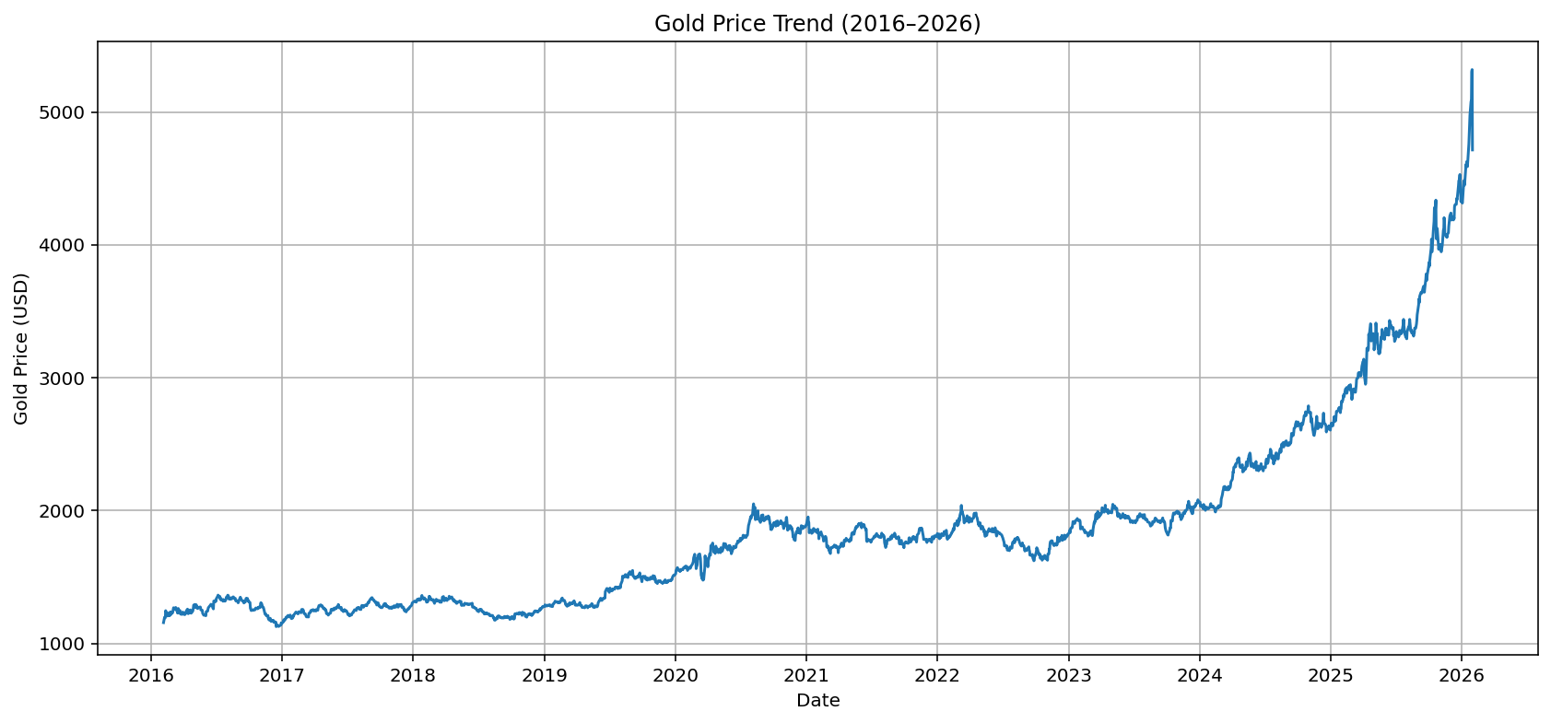The closing price of gold is plotted against time to visualize the overall market trend.
Interpretation
The trend analysis reveals the long-term direction of gold prices over the study period. Upward movements indicate increasing investor demand and safe-haven buying, while downward movements may reflect stronger economic conditions or rising interest rates.

8. Return Analysis
Daily returns measure percentage changes in gold prices from one trading day to the next.
Daily Return Formula
Rₜ = (Pₜ − Pₜ₋₁) / Pₜ₋₁
Where:
- Rₜ = Daily Return
- Pₜ = Current Day Closing Price
- Pₜ₋₁ = Previous Day Closing Price
If:
- $P_{t-1}=1800$, $P_{t}=1836$
$$R_{t}=\frac{1836-1800}{1800}=0.02$$
Daily Return = 2%
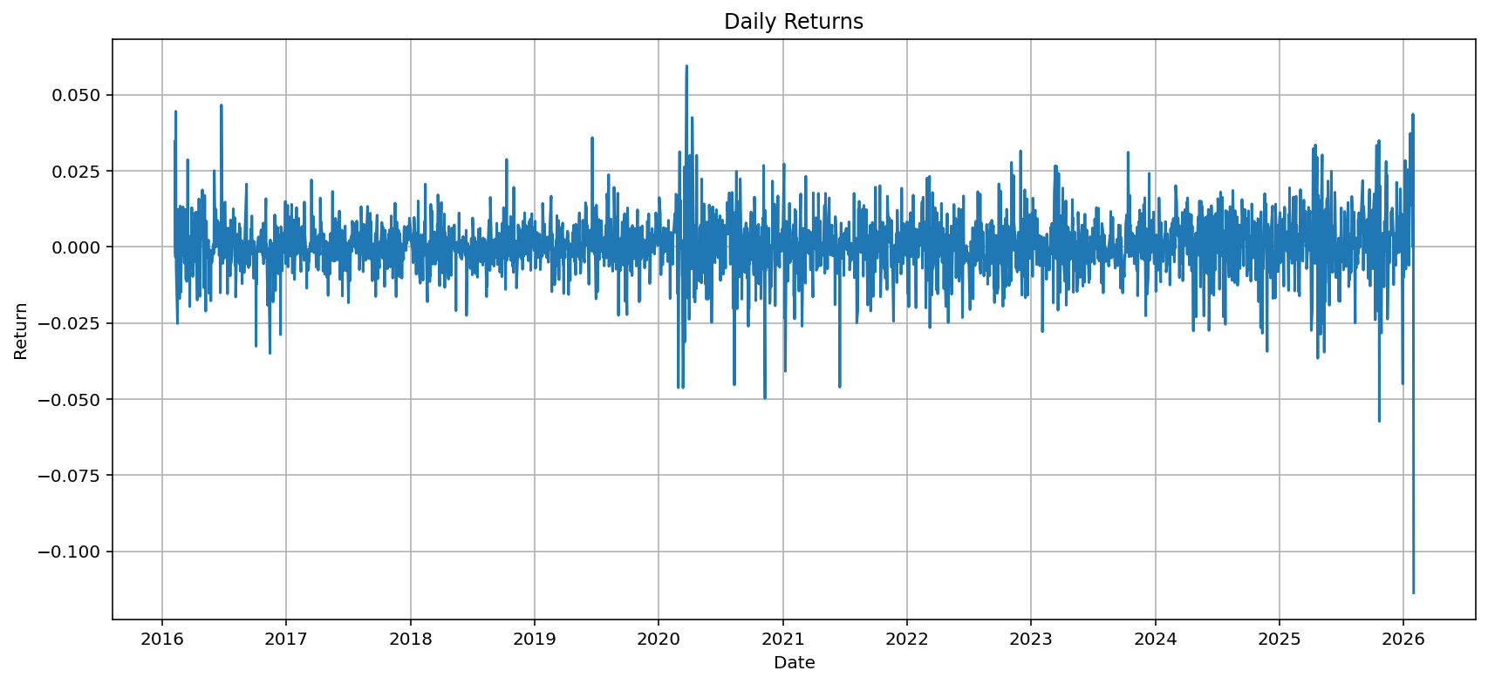The daily return series illustrates short-term price fluctuations and market reactions to economic events.
Interpretation
The daily return series captures short-term fluctuations in gold prices. Most returns fluctuate around zero, indicating market stability under normal conditions. However, large positive or negative returns reflect periods of high uncertainty, often driven by macroeconomic or geopolitical events.
9. Volatility Analysis
Volatility is a measure of risk and represents the degree of variation in asset returns over time.
A 30-day rolling standard deviation of daily returns is used to estimate volatility.
Volatility Formula
σₜ = Std(Rₜ₋₂₉ ... Rₜ)
Assume 5 daily returns:
Day | Return
1 | 0.01
2 | -0.02
3 | 0.03
4 | 0.00
5 | -0.01

Step 1: Mean Return
$$\overset{ˉ}{R}=\frac{0.01-0.02+0.03+0.00-0.01}{5}=0.002$$
Step 2: Deviations from Mean
- (0.01 − 0.002)² = 0.000064
- (-0.02 − 0.002)² = 0.000484
- (0.03 − 0.002)² = 0.000784
- (0.00 − 0.002)² = 0.000004
- (-0.01 − 0.002)² = 0.000144
Sum = 0.00148
Step 3: Variance and Volatility
$$σ^{2}=\frac{0.00148}{5}=0.000296 \\ σ=\sqrt{0.000296}≈0.0172$$
Result
30-day (illustrative) Volatility ≈ 0.0172 = 1.72%

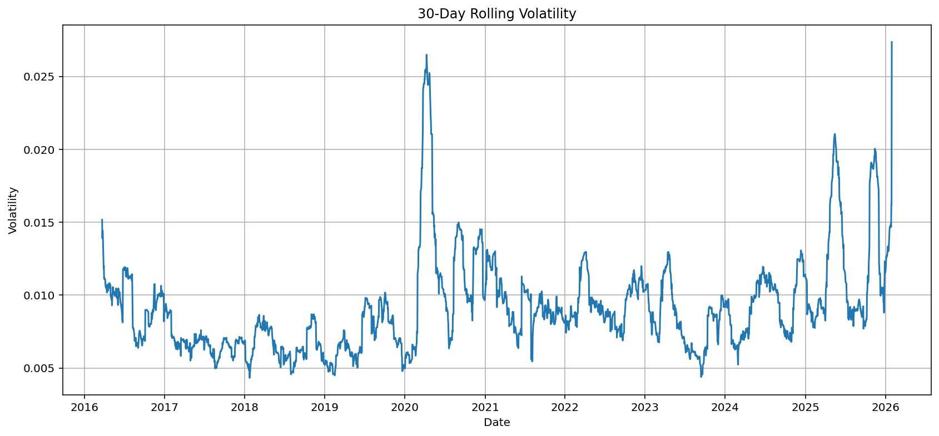This graph shows how gold market risk changes over time.
Interpretation
Volatility represents the level of risk in the gold market. Higher volatility indicates greater uncertainty and is often observed during financial crises, inflation shocks, or geopolitical tensions. Lower volatility reflects more stable market conditions and reduced risk in price movements.
10. Moving Average Analysis
Moving averages smooth short-term fluctuations and reveal the underlying market trend.
10.1 50-Day Moving Average
The 50-day moving average reflects medium-term market behavior and responds relatively quickly to recent price changes.
10.2 200-Day Moving Average
The 200-day moving average captures long-term market direction and is widely used by institutional investors.
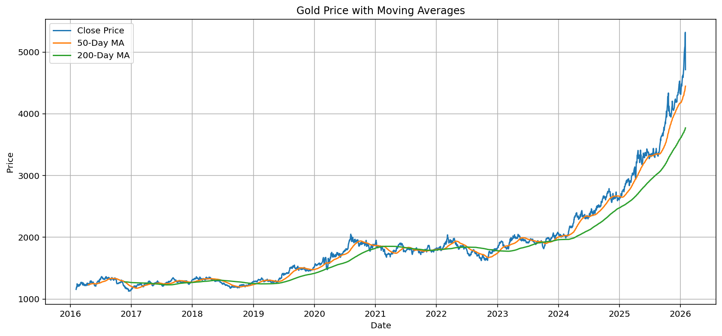The graph displays:
- Closing Price
- 50-Day Moving Average
- 200-Day Moving Average
Trading Signals
Golden Cross
Occurs when:
50-Day MA > 200-Day MA
This is generally interpreted as a bullish signal.
Death Cross
Occurs when:
50-Day MA < 200-Day MA
This is generally interpreted as a bearish signal.
Interpretation
Moving average crossovers help identify trend reversals and are commonly used in technical analysis to assess market direction.

11. Correlation Analysis
Correlation analysis measures the relationships among variables in the dataset.
Variables included:
- Open
- High
- Low
- Close
- Volume
Correlation Heatmap
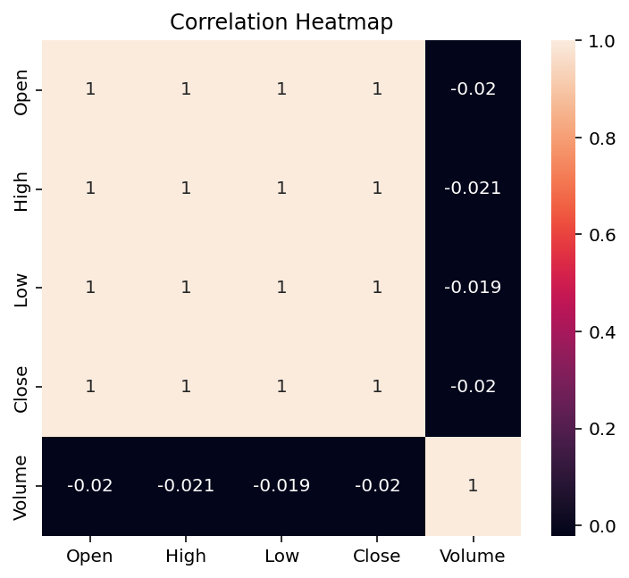
The heatmap visualizes pairwise correlations among the variables.
Interpretation
Strong positive correlations are expected among Open, High, Low, and Close prices because they represent different measurements of the same trading day. Volume typically exhibits weaker correlations with price variables.

12. ARIMA Forecasting
12.1 Stationarity Testing
Prior to model estimation, stationarity was assessed using the Augmented Dickey-Fuller (ADF) test.
Hypotheses
H₀: The time series is non-stationary.
H₁: The time series is stationary.
ADF Test Results
Metric | Value
ADF Statistic | 5.7303
p-value | 1.0000
Critical Value (1%) | -3.4330
Critical Value (5%) | -2.8627
Critical Value (10%) | -2.5674

Interpretation
The ADF statistic of 5.7303 is greater than all critical values, and the p-value of 1.0000 is substantially higher than the 0.05 significance level. Therefore, the null hypothesis of non-stationarity cannot be rejected. This indicates that the original gold price series is non-stationary and requires differencing before ARIMA modeling. Consequently, first-order differencing (d = 1) was applied in the ARIMA(5,1,0) model to achieve stationarity.

12.2 ARIMA Model
The forecasting model used in this study is:
ARIMA(5,1,0)
Where:
- 5 = Autoregressive terms
- 1 = Differencing order
- 0 = Moving average terms
The model was fitted using historical closing prices.

12.3 Forecast Generation
The fitted ARIMA model was used to forecast gold prices for the next 30 trading days.
30-Day Gold Price Forecast with 95% Confidence Intervals
Include the first 5 rows only:

Day | Forecast Price | Lower 95% CI | Upper 95% CI
1 | 4744.87 | 4694.67 | 4795.06
2 | 4763.59 | 4693.87 | 4833.30
3 | 4741.95 | 4658.65 | 4825.25
4 | 4784.52 | 4688.56 | 4880.47
5 | 4771.39 | 4665.73 | 4877.04

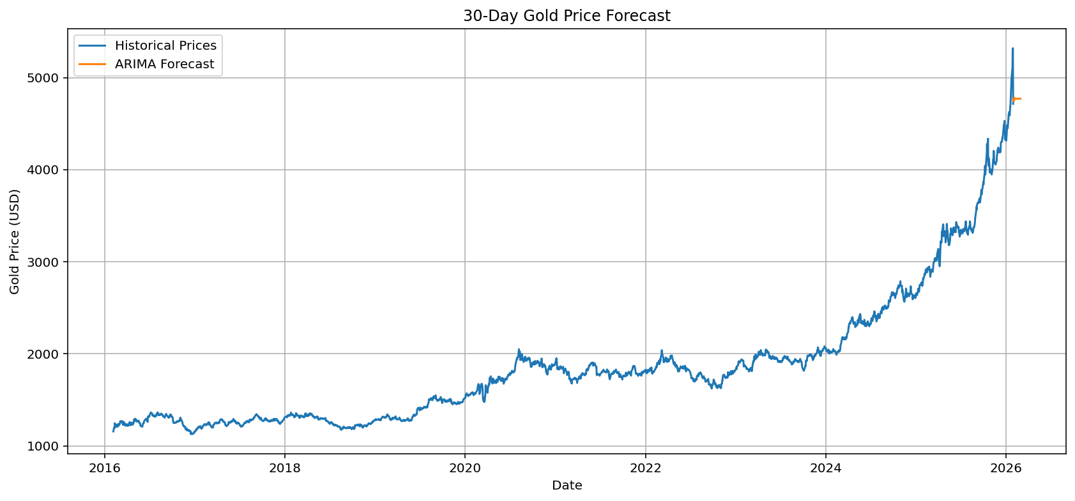
The graph displays:
- Historical Prices
- Forecasted Prices
Interpretation
The forecast provides an estimate of future gold prices based on historical patterns. While short-term forecasts can capture underlying trends, unexpected economic or geopolitical events may affect future accuracy.
12.4 Forecast Evaluation Metrics
Forecast accuracy was evaluated using standard performance measures.
Metric | Value
RMSE | 1210.25
MAE | 979.64
MAPE | Not Available

Interpretation
The ARIMA model achieved a Root Mean Squared Error (RMSE) of 1210.25 and a Mean Absolute Error (MAE) of 979.64 on the test dataset. These metrics measure the average deviation between the actual and predicted gold prices, with RMSE penalizing larger errors more heavily than MAE.
The Mean Absolute Percentage Error (MAPE) was not reported due to instability in percentage-based error calculations when actual values vary significantly and approach low-scale sensitivity issues in financial time-series data. In such cases, MAPE can produce misleading interpretations. Therefore, RMSE and MAE were used as the primary evaluation metrics for forecasting accuracy.

13. Key Events Analysis
COVID-19 Pandemic (2020)
- Safe-haven demand increased significantly.
- Gold prices reached historical highs.
- Market volatility surged dramatically.
Inflationary Environment (2021–2023)
- Rising inflation supported investor demand for gold.
- Prices remained elevated throughout the period.
Federal Reserve Rate Hikes (2022–2023)
- Higher interest rates increased the opportunity cost of holding gold.
- Downward pressure emerged on prices.
Geopolitical Tensions (2022–2024)
Global conflicts and geopolitical uncertainty contributed to increased safe-haven demand and periodic spikes in gold prices.

14. Limitations
The study has several limitations:
- The forecasting model relies primarily on historical price data and does not incorporate external macroeconomic variables such as interest rates, inflation, or exchange rates.
- The ARIMA model assumes linear relationships in the time series, which may not fully capture complex market dynamics.
- Structural breaks and unexpected economic or geopolitical events may impact forecasting accuracy.
- Cross-validation across multiple time windows was not performed, which may limit the robustness of model evaluation over different market regimes.

15. Conclusion
This project demonstrates the application of quantitative financial analysis and time-series modelling techniques to historical gold market data from 2016 to 2026.
Through trend analysis, return analysis, volatility measurement, moving average analysis, correlation assessment, and ARIMA forecasting, the study provides a comprehensive understanding of gold market behaviour.
The results highlight gold's role as a safe-haven asset during periods of economic uncertainty, inflationary pressure, and geopolitical instability. Volatility analysis identifies periods of elevated market risk, while moving averages reveal major trend changes. The ARIMA model provides a systematic approach for forecasting short-term gold price movements.
Overall, the project demonstrates how statistical and time-series techniques can support investment analysis, portfolio management, and financial decision-making.

References
- Box, G. E. P., Jenkins, G. M., & Reinsel, G. C. Time Series Analysis: Forecasting and Control.
- Tsay, R. S. Analysis of Financial Time Series.
- Hull, J. C. Options, Futures, and Other Derivatives.
- Stats models Documentation. Retrieved from https://www.statsmodels.org

- Pandas Documentation. Retrieved from https://pandas.pydata.org

- Matplotlib Documentation. Retrieved from https://matplotlib.org

- Seaborn Documentation. Retrieved from https://seaborn.pydata.org

